If you are traveling from Cinci, you’re best route to meet us in Columbus is I-71N to I-270E to I-70E and exit North on Rt. 256. According to Mapquest, I-71&Montgomery Rd. in Cinci to Rt. 256 in Columbus is about 100 miles and 1.4 hours of driving, so if you want to meet us by 10:30, you’ll need to leave Cinci by 9:00am.

You’ll need to bring a FRS radio. We’ll keep it tuned to 2-3.

Itinerary for Falling Water 2003

SATURDAY
10:30am | Meet in Columbus at:  13885 REYNOLDSBURG BALTIMORE RD  REYNOLDSBURG, OH 43068
10:45am | Leave Columbus
11:45am | Arrive Cambridge for lunch (Coney Island)
1:00pm | Leave Cambridge
4:30pm | Arrive Hampton Inn/Uniontown
5:30pm | Cocktails/Gathering
6:30pm | Dinner at:  Coal Baron Restaurant  7606 National Pike  Uniontown  724-439-0111

SUNDAY
7:00am | Breakfast (In hotel) for early tour
7:30am | Leave for Early tour
8:30am | Breakfast (In hotel) for late tour
9:00am | Leave for Late tour
12:30pm | Lunch/Brunch at:  Caileighs  105 E. Fayette Street (Rt. 40)  Uniontown, PA  724-437-9463  http://www.caileighs.com/index.htm
2:00pm | Depart for home via back roads, see map  (Those wishing can take a longer scenic route home thru the hills WV, or just hop on the freeway for the quick route)

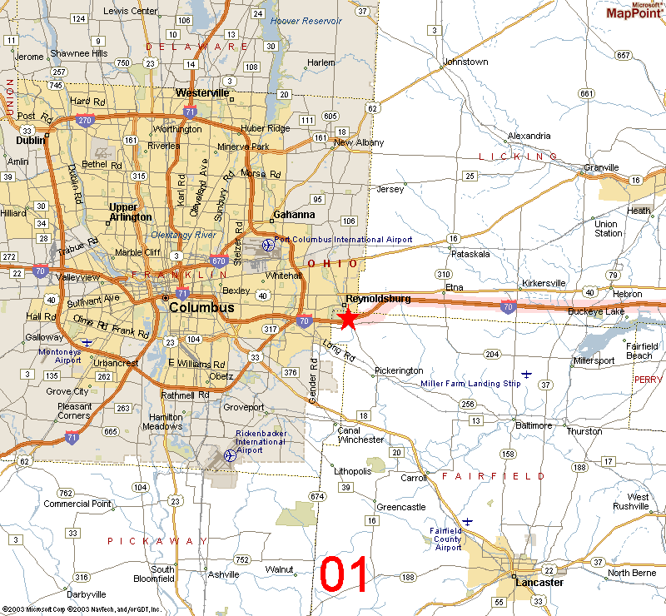 | We’ll gather at the McDonalds/Shell station on Rt. 256, just north of I-70 on the East side of Columbus. We will travel to Cambridge via I-70. We’ll have lunch there and top off our tanks.  Our starting point is:  13885 REYNOLDSBURG BALTIMORE RD  REYNOLDSBURG, OH 43068

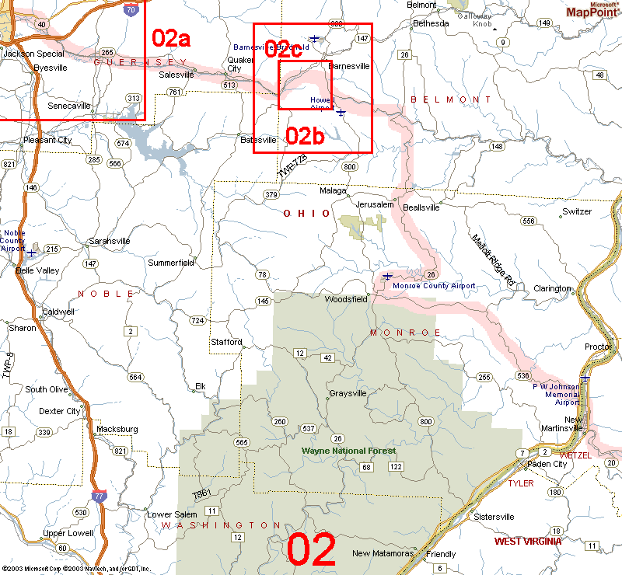 | Cambridge to  New Martinsville

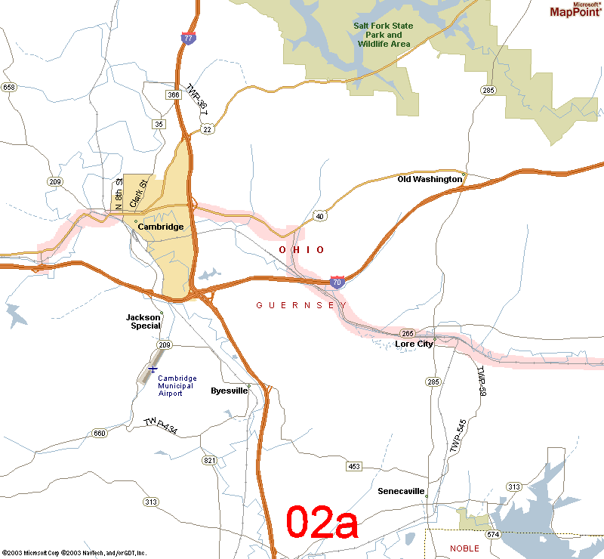 | Rt. 40E to Rt. 265E

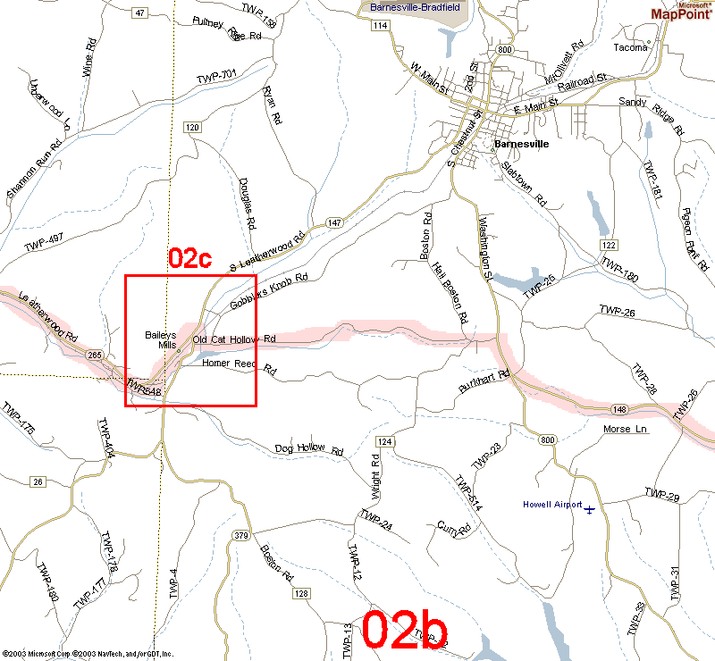 | Rt. 265E

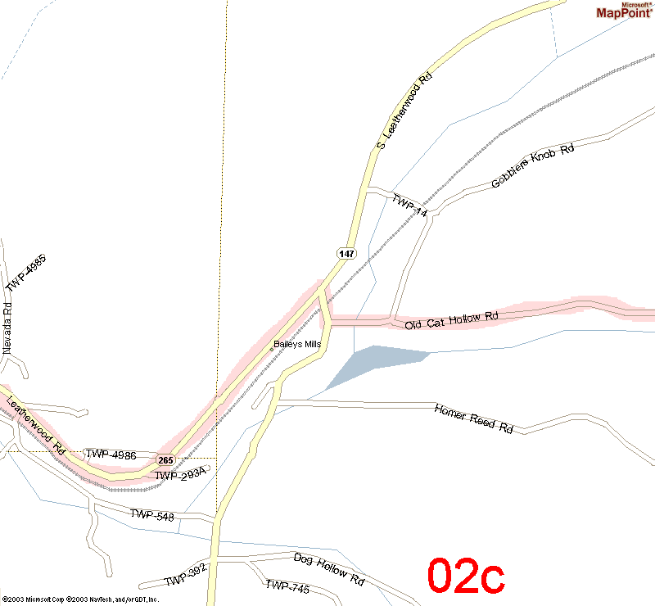 | Rt. 265E to Old Cat Hollow Road

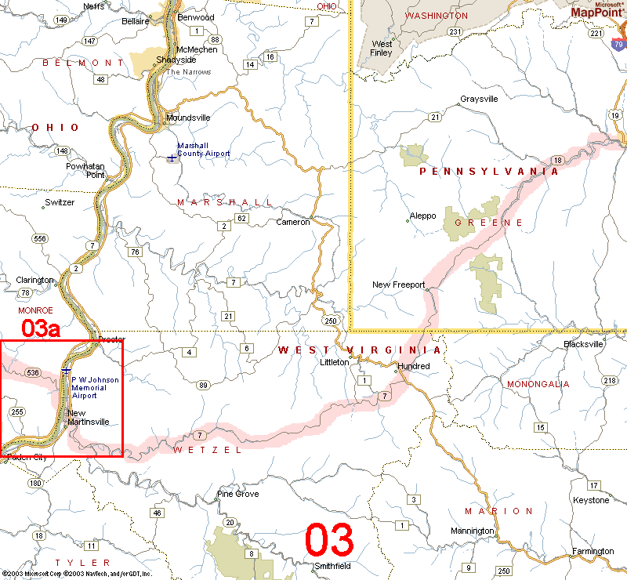 | Across WV…
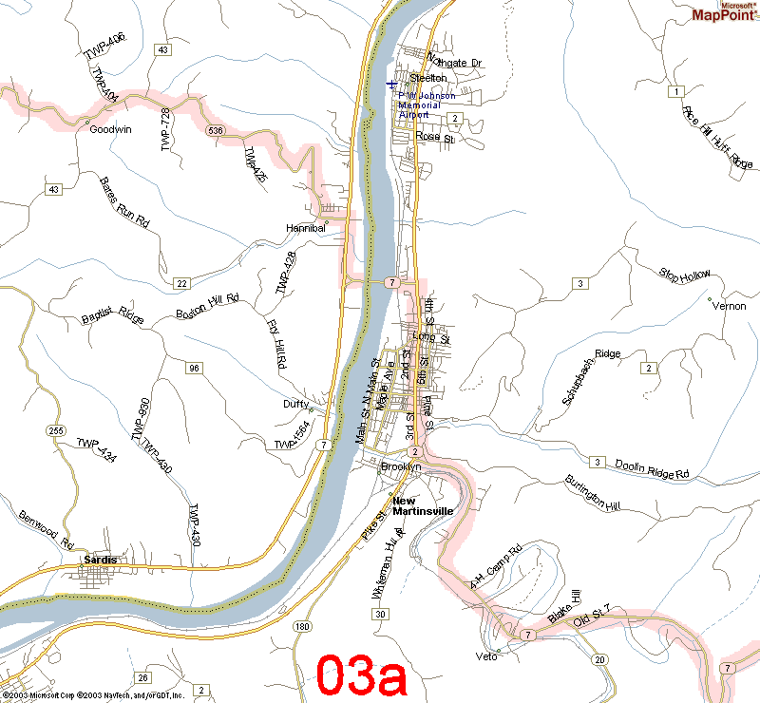 | Rt. 2S to Rt. 7E

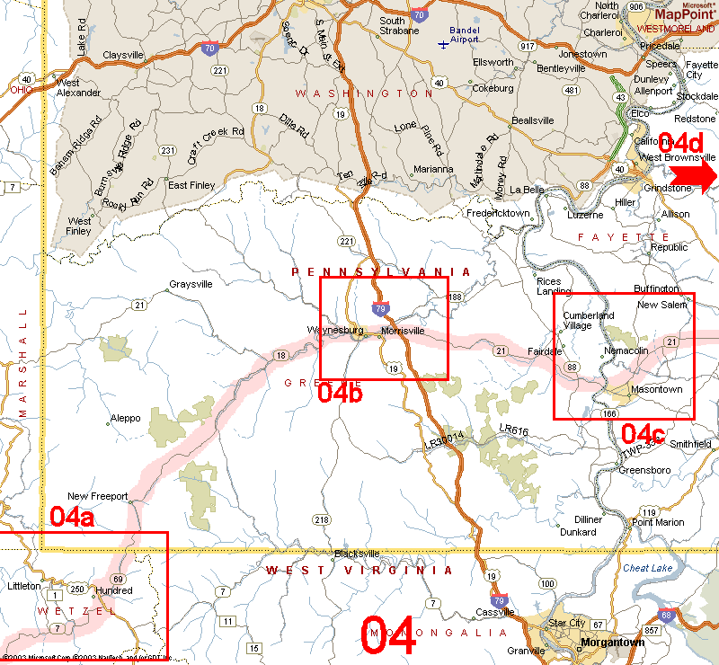 | Rt. 7E to Rt. 69N to Rt. 18N/E to Rt. 21E

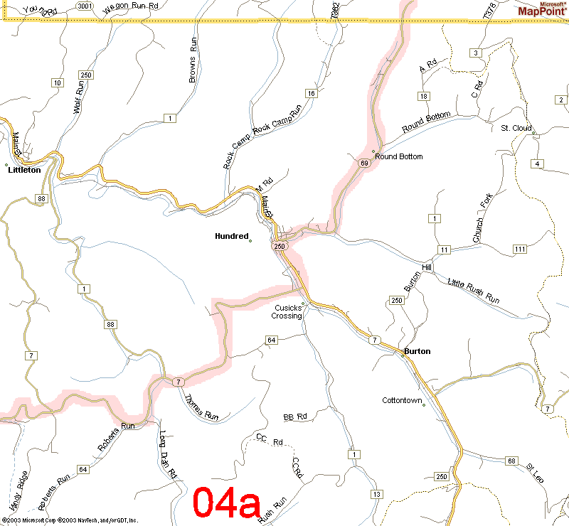 | Rt. 7E to Rt. 250N to Rt. 69N  (becomes PA Rt. 18)
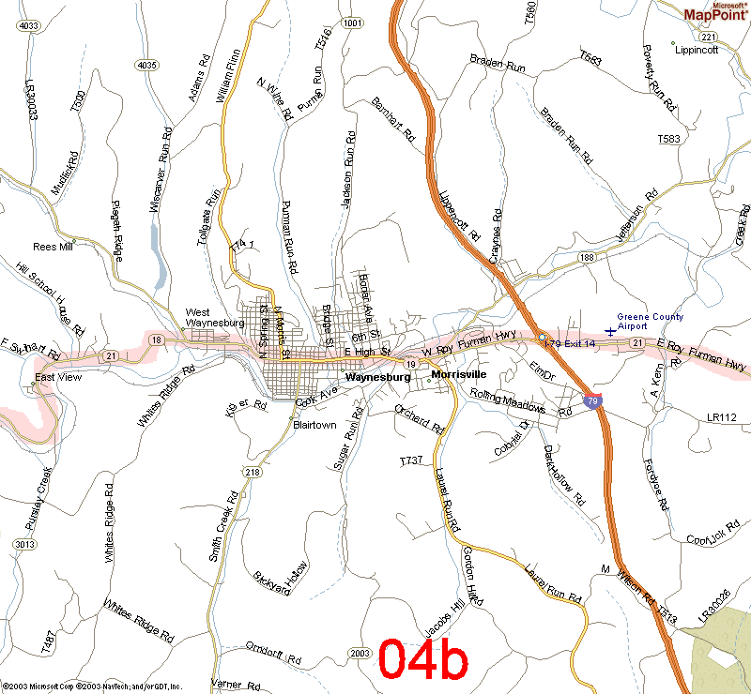 | Rt. 21E thru Waynesburg

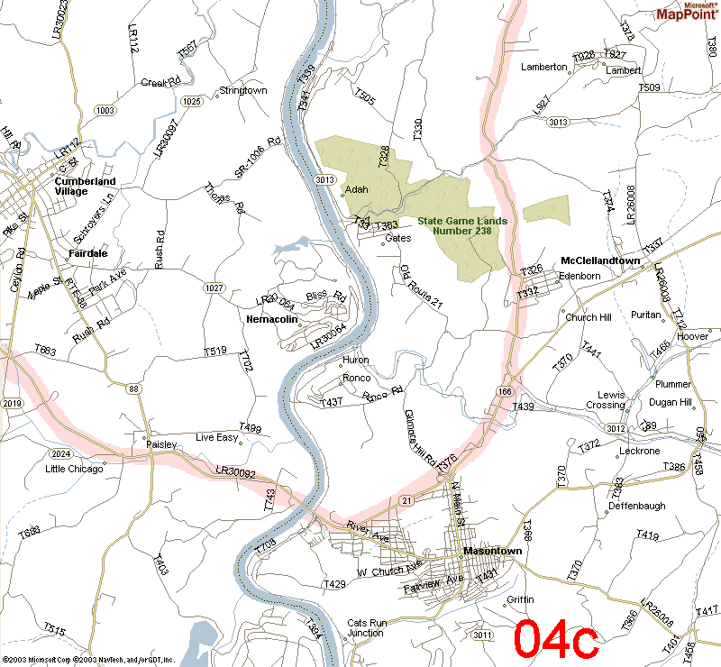 | Rt. 21E thru Masontown

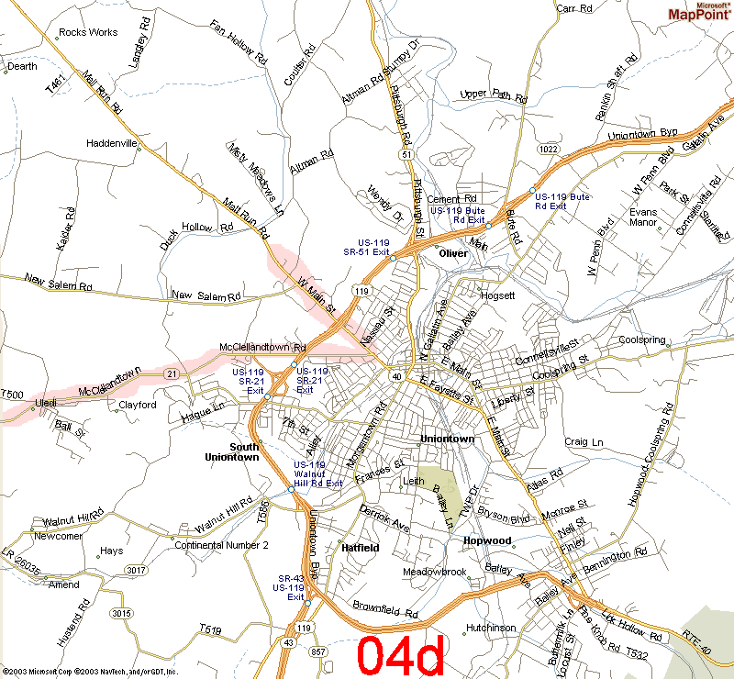 | Rt. 21E to Rt. 40W (Hampton Inn)  698 West Main Street  Uniontown, PA 15401  1-724-430-1000

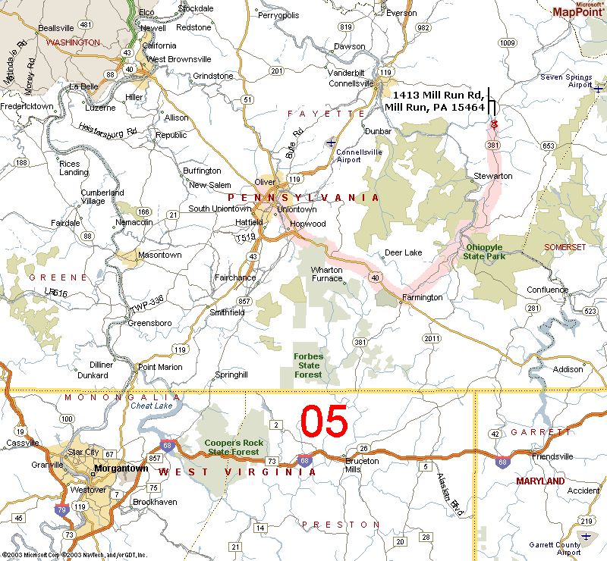 | Falling Water House

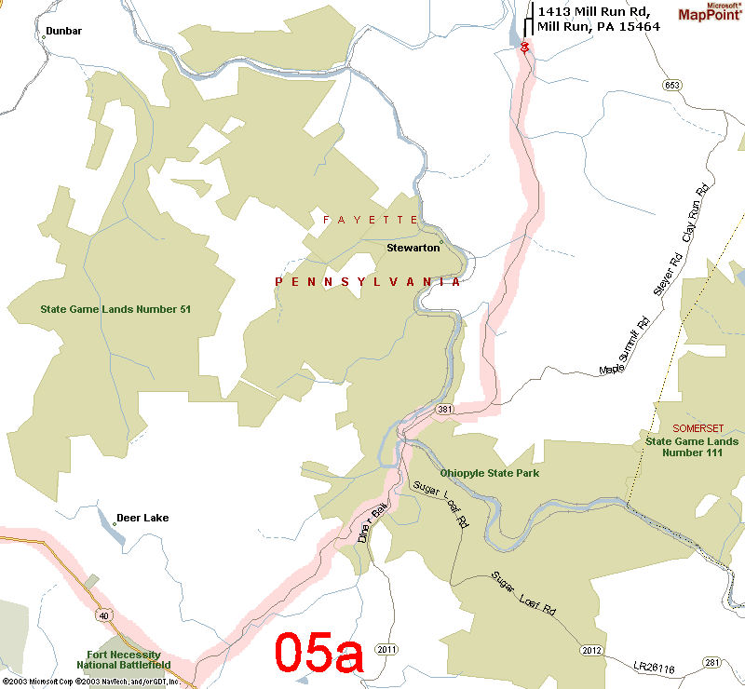 | Rt. 40E to Rt. 381N

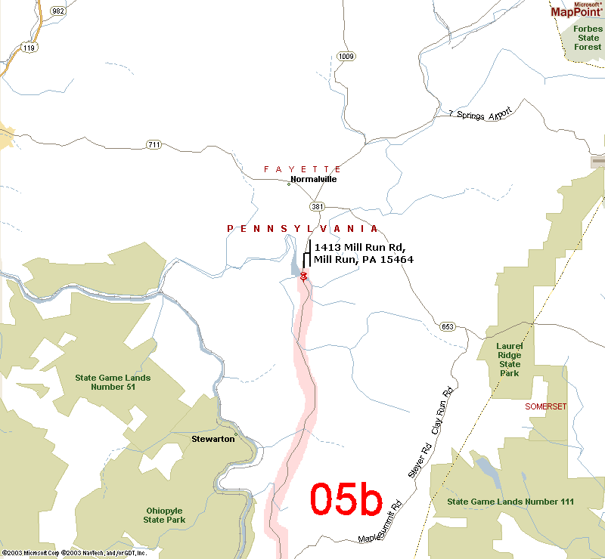 | Rt. 381N to Falling Water House

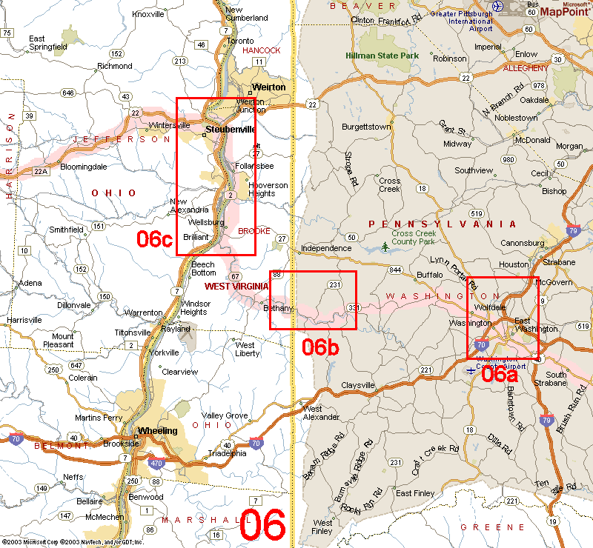 | Washington PA to Cambridge OH

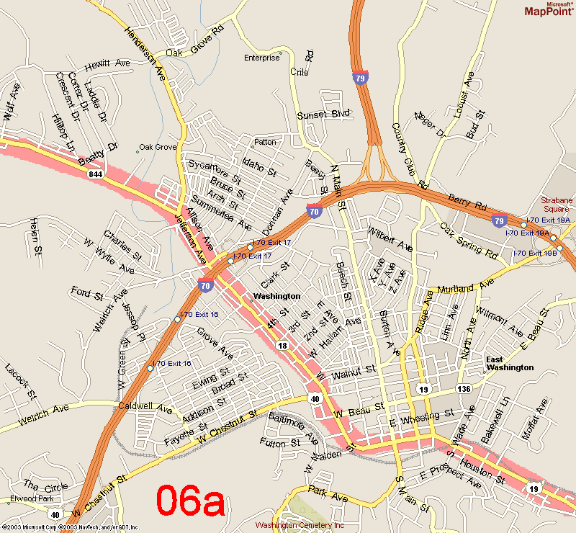 | Rt. 40W to Rt. 844W

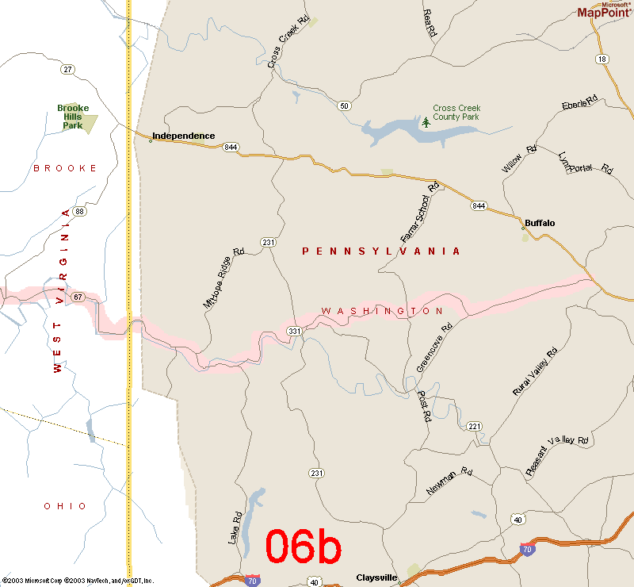 | Rt 331W (Brush Run Rd?) becomes Rt. 67W

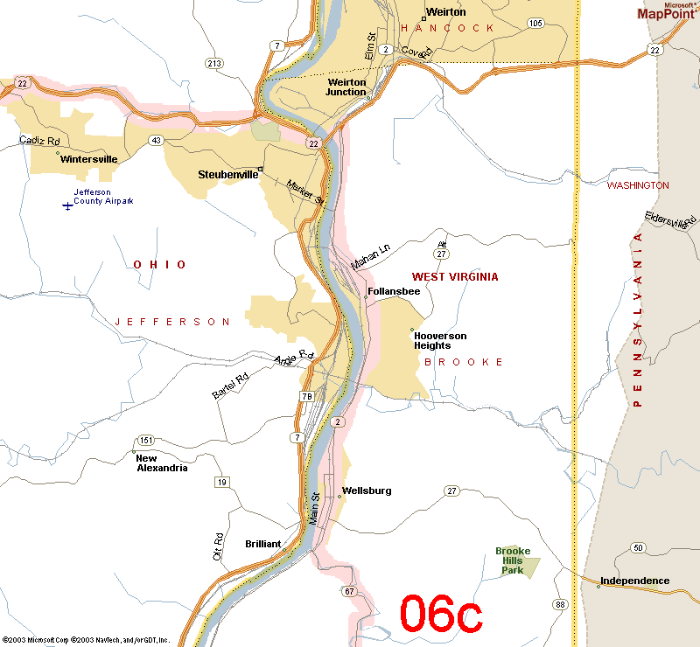 | Rt. 67W to Rt. 2N to Rt. 22W  From here, we end up in Cambridge and can take I-70 back to Columbus and/or Cinci.

